Fish Analysis OCNMS

Ole Shelton

10/07/2018

# Exploratory analysis

These are some analyses based on the 2015-19 survey data for fish. I’ve done a bunch of processing in the Git repo (file “/GitHub/OCNMS/R scripts/Fish, Invert, Kelp Analysis/Swath Fish.R”).

I first plotted a bunch of species together to look at the fish community. Then I plot individual species by site and time.

During the sampling, the sampling they observed a total of 31 species and species groups. A few of these are redundant, though. Here is how the sampling was distributed across sites and depths among years (underscores indicate sampling depth).

## site 2015_5 2016_5 2016_10 2017_5 2017_10 2018_5 2018_10  
## 1 Destruction Island 0 4 6 8 6 8 7  
## 2 Teahwhit Head 4 0 0 0 0 0 0  
## 3 Cape Johnson 4 6 6 8 8 8 7  
## 4 Rock 305 4 0 0 0 0 0 0  
## 5 Cape Alava 4 6 6 8 11 8 8  
## 6 Point of the Arches 6 0 0 0 0 0 0  
## 7 Anderson Point 4 0 0 0 0 0 0  
## 8 Tatoosh Island 4 4 4 6 7 8 7  
## 9 Chibadehl Rocks 4 0 0 0 0 0 0  
## 10 Neah Bay 7 4 6 8 8 7 8  
## 2019_5 2019_10  
## 1 8 8  
## 2 0 0  
## 3 8 7  
## 4 0 0  
## 5 8 8  
## 6 0 0  
## 7 0 0  
## 8 8 6  
## 9 0 0  
## 10 7 8

Here is a cheat sheet for species abbreviations and associated common names (ordered by abbreviation):

## species common.name  
## 1 ARHA <NA>  
## 2 AUFL Tubesnout  
## 3 BAITBALL Bait, Sardines/Anchovies  
## 4 CHNU Mosshead warbonnet  
## 5 CLUP Sardines and anchovies  
## 6 COTT Sculpins  
## 7 EMBI Surfperches  
## 8 EMLA Striped Surfperch  
## 9 ENBI Buffalo Sculpin  
## 10 HEDE Kelp Greenling  
## 11 HEHE Red Irish Lord  
## 12 HELA Rock Greenling  
## 13 HEST Whitespotted greenling  
## 14 JOZO Longfin Sculpin  
## 15 MYOPOL <NA>  
## 16 NO_ORG No organisms present in this sample  
## 17 OPEL Lingcod  
## 18 OXPI Painted Greenling  
## 19 RHNI Blackeye Goby  
## 20 RHVA Pile perch  
## 21 RIMU Kelp clingfish  
## 22 RYOY Rockfish young of the year, unidentified sp.  
## 23 SCMA cabezon  
## 24 SEBYTy black and yellowtail rockfish YOY complex  
## 25 SECA copper rockfish  
## 26 SEFL Yellowtail rockfish  
## 27 SEMA Quillback rockfish  
## 28 SEME black rockfish  
## 29 SEMY blue rockfish  
## 30 SENE china rockfish  
## 31 SEPIy canary rockfish YOY  
## 32 SYGI <NA>

## Small Rockfish (<10cm)

Here are the rockfish plotted in a couple different ways. This is for all small rockfish combined. I have included all transects here, not just those with visibility > 2m. See the end for information about the transects and visibility. In the bottom panel, the black boxes and error bars are simple the among site means and SE using the site means. For all panels, the 5 vs. 10 colums indicate water depth category.

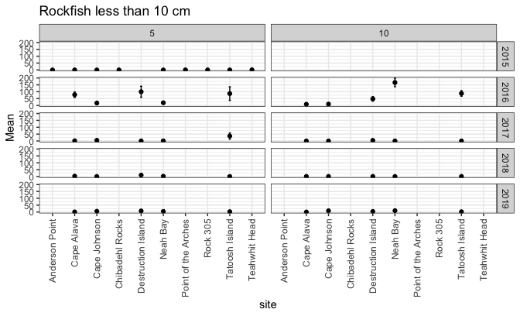 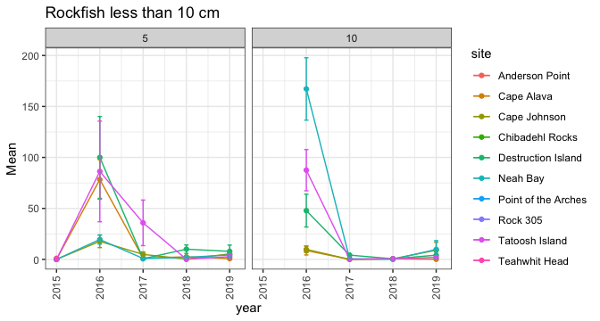 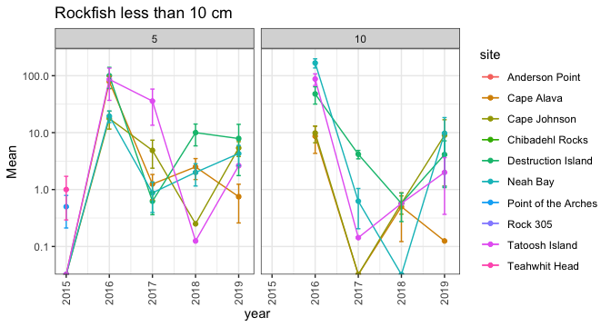

Here is why I didn’t make plots of species by sub-types. Different levels of taxonomic specificity are available for different observers and years. 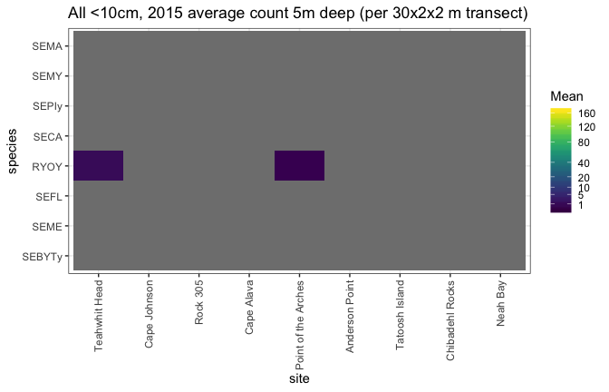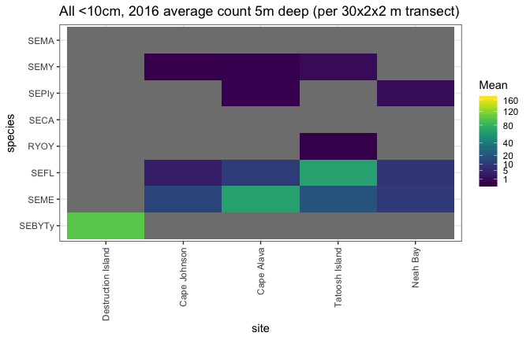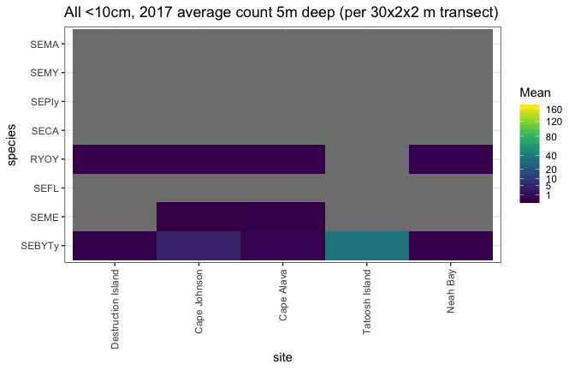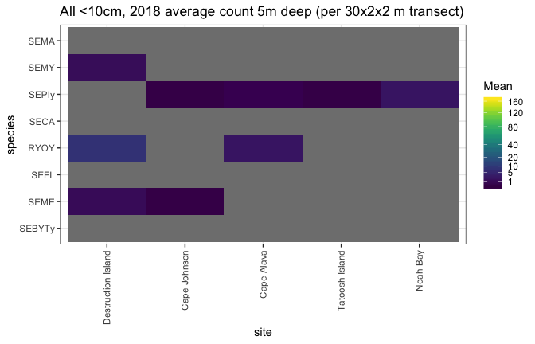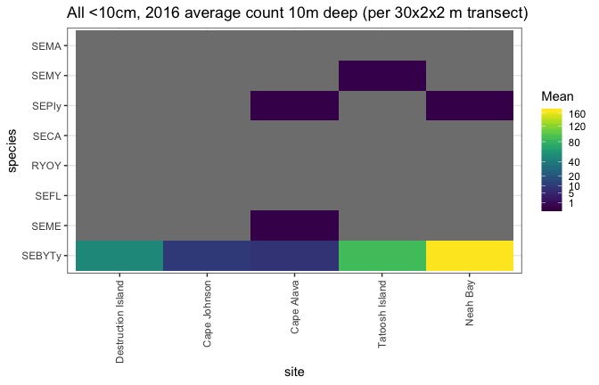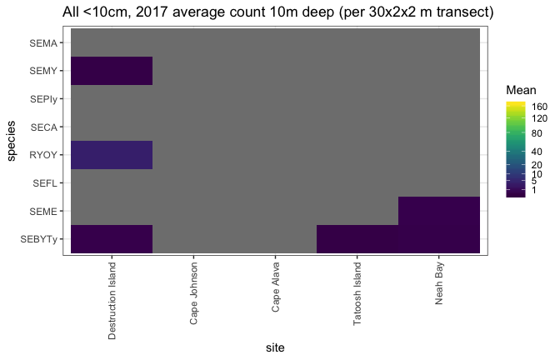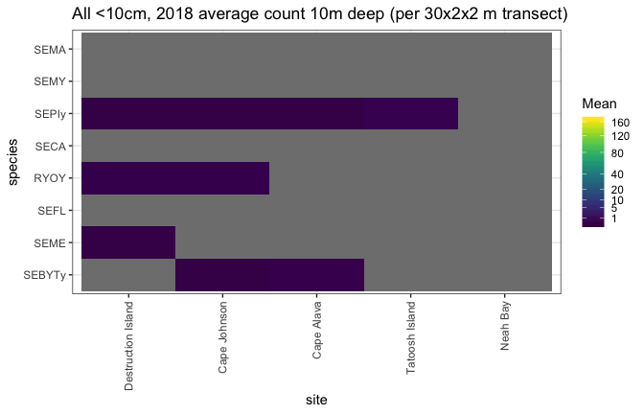

## All Other Fish Except small rockfish

Here, here are the fish > 10 cm. In general, you will notice a lot of grey in the figures. This means most species were not observed in any transect at that site-year combination.

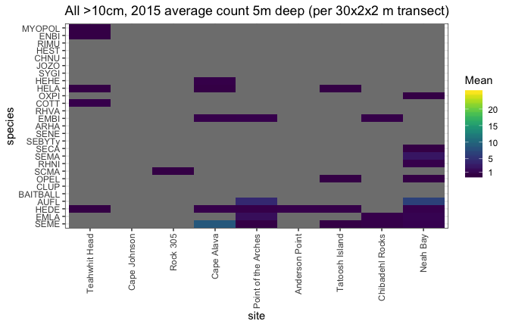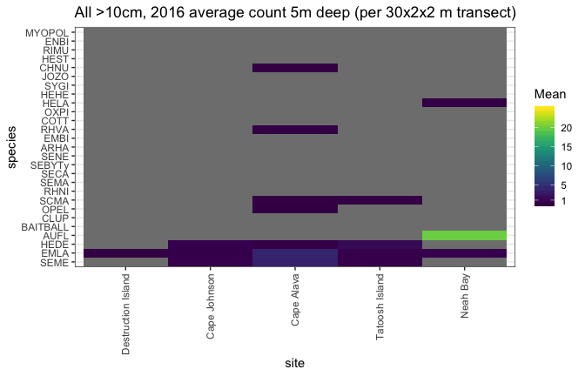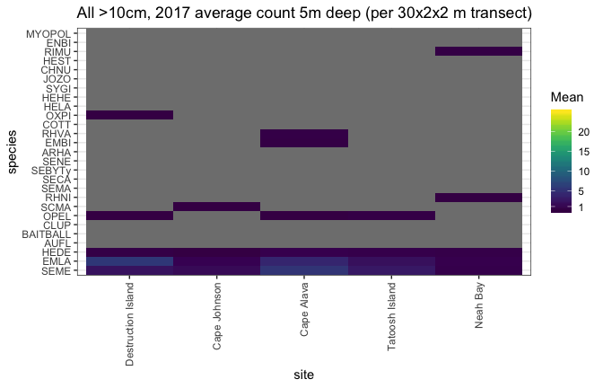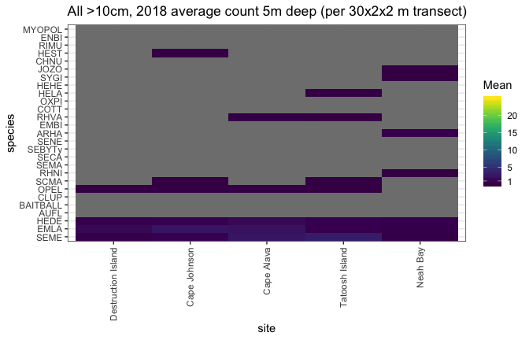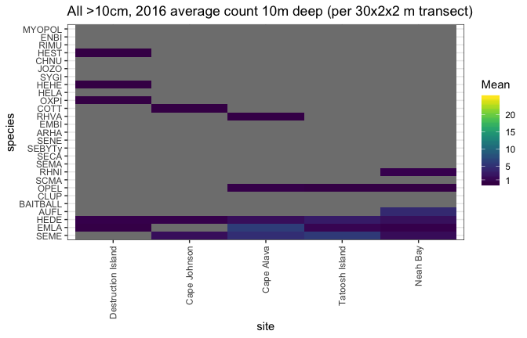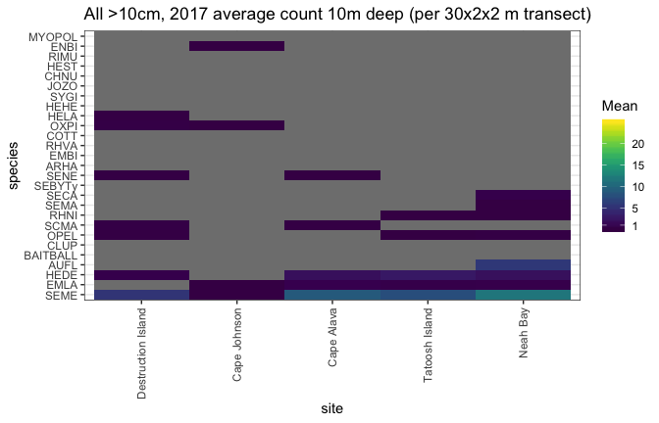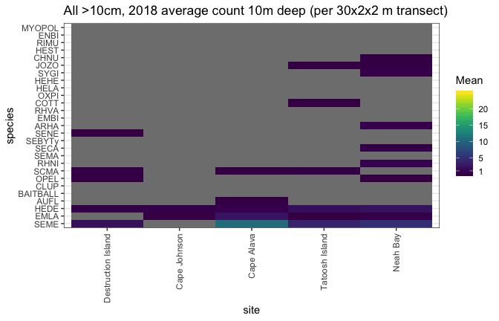 # Example time series and spatial variation for the top 8 most common species.

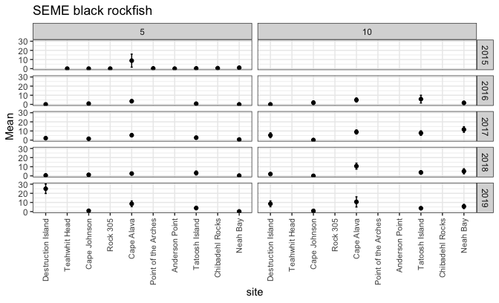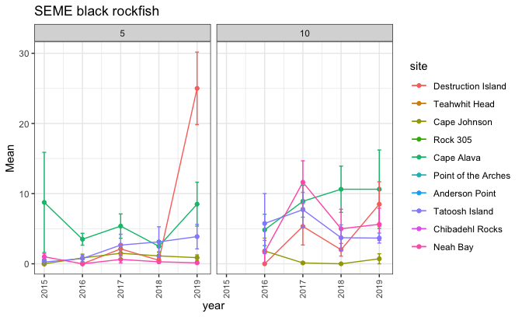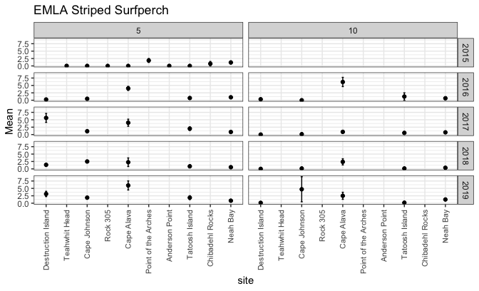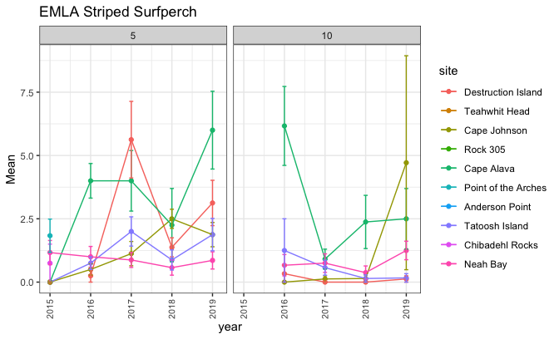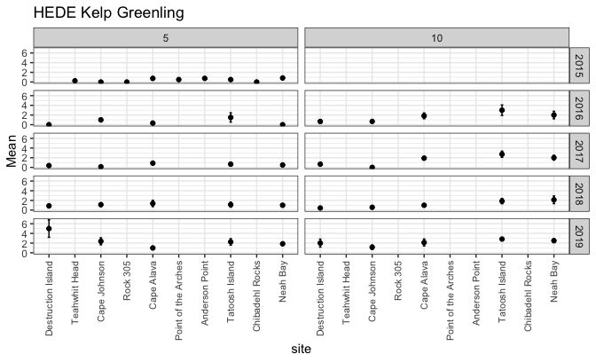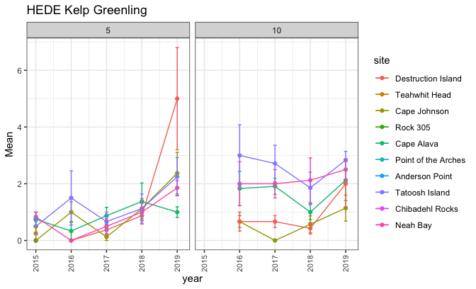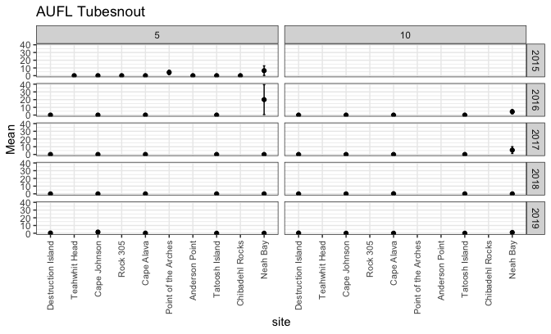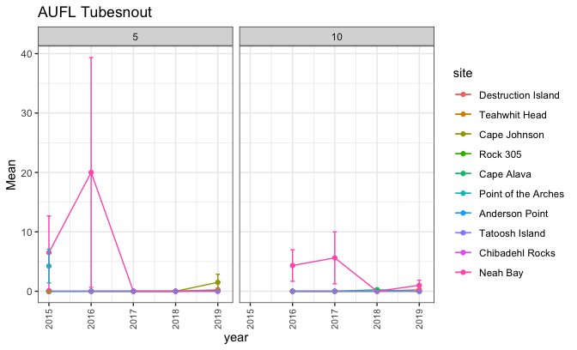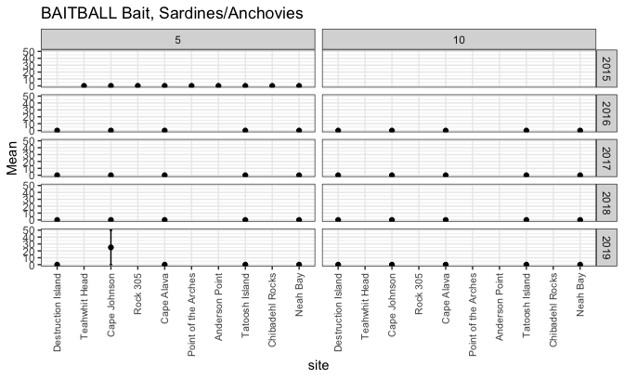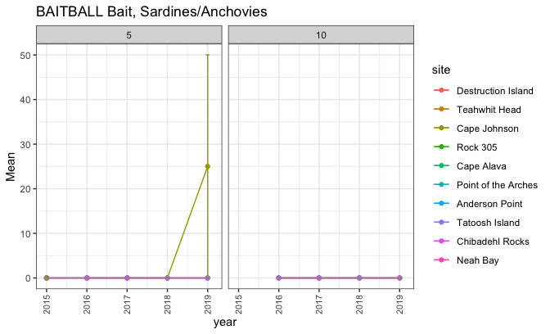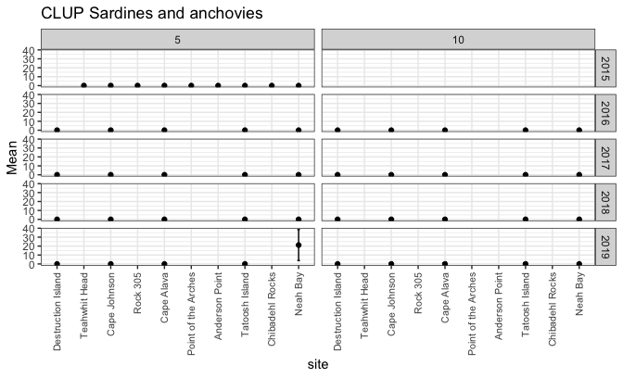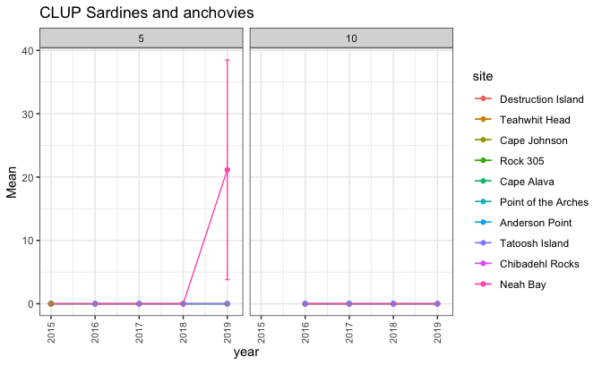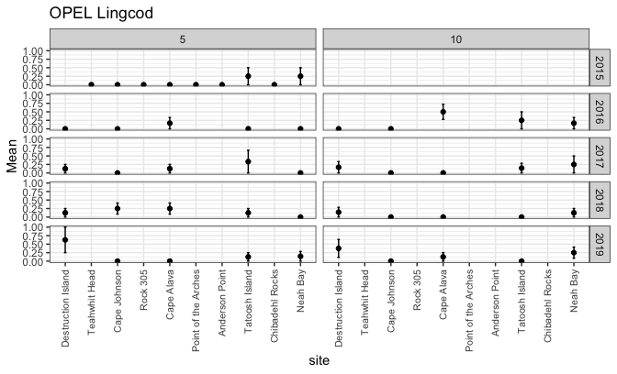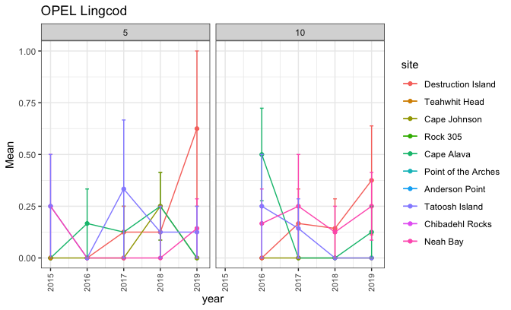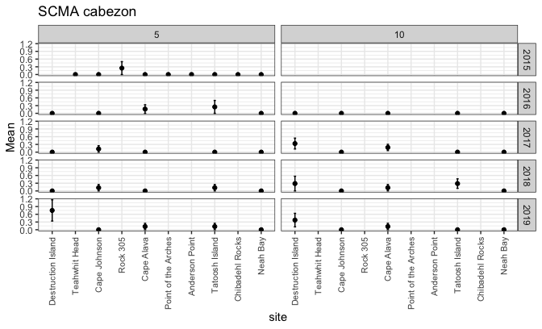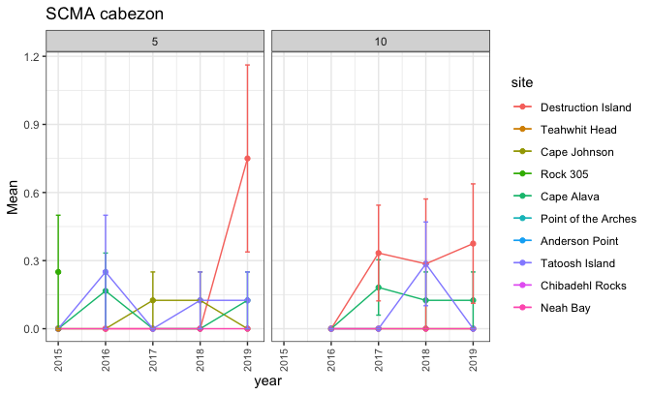

#### Some plots on visibility by site and depth zone

These suggest to me that the 2m cut off that PISCO uses is going to be problematic… there are a lot of surveys that are right on the cusp of 2m visibility. 